# Exercises: HTML5 and CSS

Problems for exercises and homework for the [“Software Technologies” course @ SoftUni](https://softuni.bg/courses/software-technologies).

We have completed the home page, along with the two pages for login and registration. Now let’s create a

# Designing the New post page

## Create the New post page

Create an html file called “new-post.html”. Set the page title to “New Post”. Import “style.css” and “form-style.css”, and after that create a new stylesheet file called “new-post-style.css” and import it to the HTML too.

This page is a form page too, but a bit different from the others.

Copy the main section and the header and the footer to it. Change the header’s content to “New Post”, and add another class besides the “blog-title” one, called “**new-post-title**”.

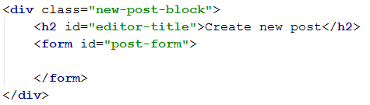

Aside from the usual main title, this page has a title on the form too. It’s in the form of a heading.

There are some changes on the side bar we need to do too.

## Designing the New post page sidebar

Redesign only the main navigation sidebar links. Name them:

**Home**

**Create Post**

**Logout**

Make the Home and Logout link redirect you to the home page and create post to the “new-post” page.

## Create new post form

Now let’s create the new post form

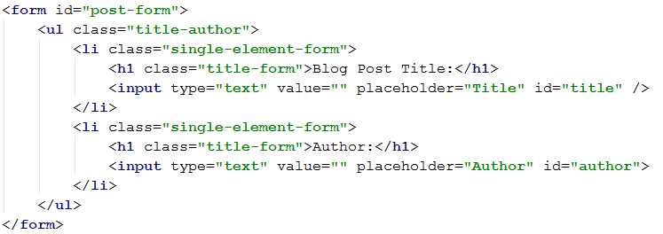

We have a list of elements for the input fields, because we would like for them to be on one line. This is for the design. Follow the above instructions exactly as they are written.

## Creating the content of the new post form

Sometimes, when large text inputs are required, it is not very appropriate to write on one line. Multiple line text however is not supported on the basic <input> tag. That is why HTML has the **<textarea>** tag.

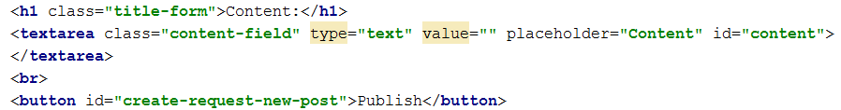

The text area will hold the content of the new post. Add a button for form data submission too.

Notice that this page does not hold a redirection button.

And with this we are ready with the new post form. Now it’s time for styling.

## Styling the title

Same as the register page title, we need to change the width of this one’s header too.

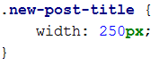

## Styling the new post form holder

Same as the other form holders, this one must be styled too:

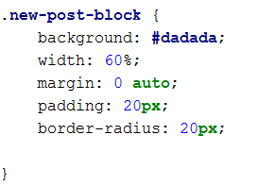

## Styling the form title

Unlike the other forms, the new post form holds a title

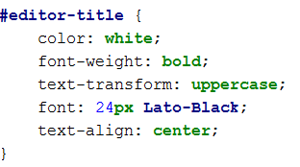

## Styling the form itself

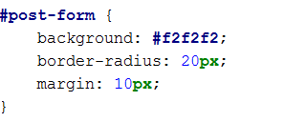

## Styling the elements in the form

The list elements that we put in the form before are finally going to get their style done.

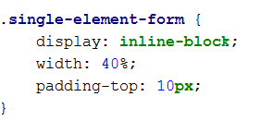

Wrapping multiple elements in one big block and setting their display property to “**inline-block**” allows us to order them in a row-like block, each, next to the other. This is why we needed the list and the list elements to structure our input fields.

## Styling the content input field of the new post form

Now let’s style the text area that accepts the input for content of the new post.

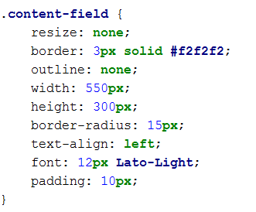

Aside from the resize and outline properties all other are familiar. The resize property specifies whether or not, the element should be resizable by the user. The outline property specifies the outline of the text area. Setting it to **“none”** removes the text area outline.

Now the content input text area should also have an “on focus” effect. Implementing that functionality is up to you. Write the style for the on focus effect so that it holds the following changes:

**Font size – 12px**

**Font family – Lato**

**Font weight – 100**

**Make it so that it has no outline**

**And set its border to 3px width, solid, and the color is #06c0ab**

## Revision

If you have done everything correctly and you have followed all of the instructions, you should see this layout:

